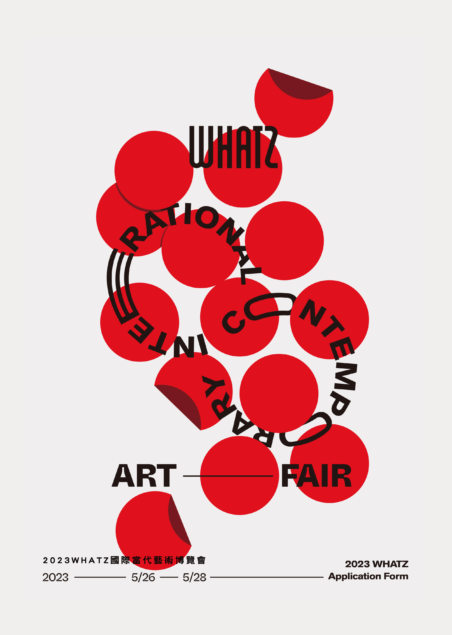

- PREFACE

WHATZ offers the opportunity for collectors and visitors to browse and buy original and limited edition artworks from some of the world’s most talented artists in Taiwan.

- IMPORTANT DATES
Early Bird Application Deadline 15 January 2023
Application Deadline 31 January 2023
Notification of Application Results 10 February 2023
Payment Deadline 28 February 2023
Fair Dates 26-28 May 2023

- VENUE

Sheraton Grand Taipei Hotel
(No.12, Section 1, Zhongxiao East Road, Zhongzheng District, Taipei, Taiwan)

Sheraton Grand Taipei Hotel is located at one of the arts & culture hubs in Taipei with taxi stand and valet parking slots available, plus one-minute walking distance from Shandao Temple MRT Station. The hotel is an excellent place for art collectors and enthusiasts to discover contemporary artworks from all over the world.

- HOW TO APPLY?
Applicants should send the complete and signed application form with other required documents to WHATZ via email (info@whatz.info). Email subject should be named as: “Name of Artist/Gallery_Application for WHATZ 2023.

Gallery and artist applicants can choose to participate in one of the below sectors, with no restrictions on the age of proposed artists and work medium.

Sector | A | B | C | D
Room size | 66m² | 50m² | 40m² | 32-35m²
Exhibition fee | USD 6,381  + 5% Business Tax  =USD 6,700 | USD 5,000  + 5% Business Tax  =USD 5,250 | USD 4,000  + 5% Business Tax  =USD 4,200 | USD 3,281  + 5% Business Tax  =USD 3,445
Fee Includes
- 3-day exhibition space
- 4-night accommodation & daily breakfast for two
- PR tickets
- Exhibitor badges
- Listing in WHATZ e-catalogue

- Applicants must remit a deposit of USD 1,000 prior to submission of application.
- To enjoy the early bird rate, applicants must file a complete application with application deposit settled before 15 January 2023.

Application deposit should be remitted to:
Beneficiary Name | WHATZ ART CO., LTD | Account Number | 0956-441-169775
Bank | E.SUN Commercial Bank, Ltd | Swift Code | ESUNTWTP

APPLICATION FORM
I wish to apply for:
A  66m² | B  50m² | C  40m² | D  32-35m²

Primary Contact Details
Name
Email
Telephone
LINE ID
Address
City
Postal Code
Country

Proposed Artists and Artworks
All applicants should submit a minimum of 2 artwork images in JPG files (300 dpi) per artist.

Proposed Artist 1
Name
Artwork 1
Title/ Thumbnail
Artwork 2
Title/ Thumbnail

Proposed Artist 2
Name
Artwork 1
Title/ Thumbnail
Artwork 2
Title/ Thumbnail

Proposed Artist 3
Name
Artwork 1
Title/ Thumbnail
Artwork 2
Title/ Thumbnail
If there is not enough space above, please insert new table(s) to provide necessary details.

An application deposit of USD 1,000 must be remitted prior to submission, with remittance slip attached below.

Terms & Conditions
- Applicants should send the complete and signed application form with 2 artwork images per proposed artist to info@whatz.info. Email subject should be named in this manner: “Name of Artist/Gallery_Application for WHATZ 2023.”
- Applicants should remit an application deposit of USD 1,000 via bank transfer prior to submission, all banking charges are borne by the applicants. Early bird rate will be honored to applicants whose application is approved with deposit settled before 15 January 2023.
- A. WHATZ reserves the right to review and reject any applications.
B. If your application is accepted, the deposit will be credited in full against the exhibition fee. In case your application is rejected, the deposit will be refunded in full.
C. Subject to Clause 6D, the deposit will not be refunded should any applicants wish to withdraw their applications.
- WHATZ will confirm upon receipt of the application materials, applicants should contact the organizer (info@whatz.info) if they do not receive an email confirmation within 5 working days.
- WHATZ has final right on room assignment. WHATZ will act to their best ability to assign the most desirable room to successful applicants. Such decisions are final.
- Ａ. Successful applicants should settle the exhibition fee in full by 28 February 2023, all outgoing and incoming banking charges are borne by applicants.
B. WHATZ reserves the right to cancel the agreement in accordance with this Terms & Conditions if the payments are not received by the dates specified above. Payment date will be taken reference to the date on the remittance slip. If applicants fail to make payment within the deadlines, any payments made will be forfeited, with the organizer to withdraw your room and offer it to a waitlisted applicant.
Ｃ. WHATZ will issue an official receipt and provide to Exhibitors at the fair.
D. The organizer shall not be liable for any delay or cancellation of the fair, or loss caused by any act of God, terrorist activity, political unrest, riot, typhoon or other inclement weather conditions, infectious disease outbreak or other event, fact or circumstance beyond the organizer’s reasonable control. In the event if the fair is cancelled, applicants may opt to ask for a full refund or retain any amount paid for the next fair.
- Applicants should make a record of all application materials prior to submission to the fair organizer. If the information provided in the application form fails to be true and accurate, the fair organizer reserves the right to reject the application.
- The Applicant (Exhibitor) shall comply with and observe all laws and regulations relevant to its use of the exhibition space at the fair, including but not limited to the house rules of the venue and intellectual property laws. The Applicant (Exhibitor) indemnifies the organizer and holds the organizer harmless against all loss, damages, claim and costs, including reasonable attorney’s fees resulting from their use of the exhibition space and the acts and omissions committed by the Applicant (Exhibitor) and its agents, servants and invitees.
- The organizer shall not be responsible for theft, damage and safety of all goods, decorations and other items brought into the venue by the Applicant (Exhibitor), its agents, employees or sub-contractors. The Applicant (Exhibitor) shall take out and maintain adequate insurance, which shall not entitle the insurers to exercise any subrogation rights against the organizer, and the Applicant (Exhibitor) shall on demand provide sufficient evidence of such insurance to the organizer.
- Any artwork images submitted by the Applicant (Exhibitor) to the organizer may be used as part of the publicity for the upcoming and future fairs. Both the artist and the Applicant (Exhibitor) will be credited where possible. The Applicant (Exhibitor) is responsible to certify that the artist has authorized the use of one’s artwork images before submitting to the organizer.
- Applicants (Exhibitors) have seven (7) days to read and understand the terms and conditions set out herein upon receipt of the countersigned application form from the organizer. Applicants (Exhibitors) should arrange payments and submit all necessary materials in accordance with the agreed payment schedule.

Disclaimer
I hereby confirm that the information provided herein is accurate, complete and that the materials submitted along are genuine. I have also read and agreed to comply with the terms and conditions set-out by WHATZ and resolve future disputes through arbitration.
Name |  | Signature |  | Date

